Project Design Phase-II Technology Stack (Architecture & Stack)

|  |  |
| --- | --- |
| Date | 16 October 2022 |
| Team ID | PNT2022TMID43983 |
| Project Name | Plasma Donor Application |
| Maximum Marks | 4 marks |

# Technical Architecture:

The Deliverable shall include the architectural diagram as below and the information as per the table1 & table 2

# Example: Order processing during pandemics for offline mode

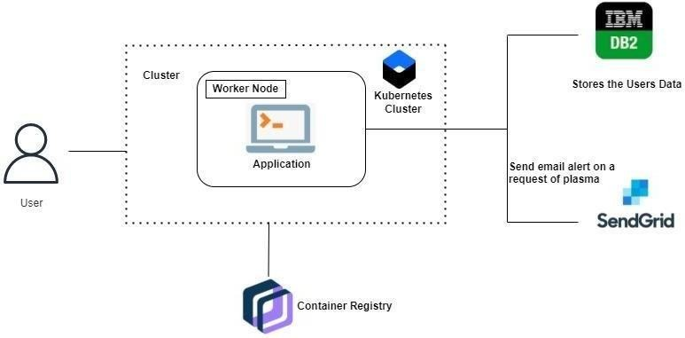

Guidelines:

1. Include all the processes (As an application logic / Technology Block)
2. Provide infrastructural demarcation (Local / Cloud)
3. Indicate external interfaces (third party API’s etc.)
4. Indicate Data Storage components / services
5. Indicate interface to machine learning models (if applicable)

**Table-1 : Components & Technologies:**

|  |  |  |  |
| --- | --- | --- | --- |
| **S.No** | **Component** | **Description** | **Technology** |
| 1. | User Interface | How user interacts with application e.g. Web UI, Mobile App, Chatbot etc. | HTML, CSS, bootstrap, JavaScript |
| 2. | Application Logic-1 | Logic for a process in the application | Python, Flask |
| 3. | Application Logic-2 | Logic for a process in the application | IBM Watson service |
| 4. | Application Logic-3 | Logic for a process in the application | IBM Watson Assistant |
| 5. | Database | Data Type, Configurations etc. | IBM DB2 |
| 6. | Cloud Database | Database Service on Cloud | IBM Cloud |
| 7. | File Storage | File storage requirements | Docker, Kubernetes |
| 8. | External API-1 | Purpose of External API used in the application | Connect to Backend |
| 9. | External API-2 | Purpose of External API used in the application | Connect to Third party application |
| 10. | Infrastructure (Server / Cloud) | Application Deployment on Local System / Cloud Local Server Configuration:  Cloud Server Configuration: | Local, IBM Cloud , Kubernetes, etc. |

# Table-2: Application Characteristics:

|  |  |  |  |
| --- | --- | --- | --- |
| **S. No** | **Characteristics** | **Description** | **Technology** |
| 1. | Open-Source Frameworks | List the open-source frameworks used | Flask |
| 2. | Scalable Architecture | Justify the scalability of architecture (3 – tier, Micro- services) | Lambda |
| 3. | Availability | Justify the availability of application (e.g. use of load balancers, distributed servers etc.) | Dynamo DB |

|  |  |  |  |
| --- | --- | --- | --- |
| **S. No** | **Characteristics** | **Description** | **Technology** |
| 4. | Performance | Design consideration for the performance of the  application (number of requests per sec, use of Cache, use of CDN’s) etc. | Send GRID |